Home Project
5/11/2021

Thanh Nhan Tong
5/11/21
2020-2021
9th Grade
Mr. Cepeda

Engineering By Design
thto8674@student.harmonytx.org

Table of Contents
5/11/21 | Introduction | 1
5/11/21 | Design Brief | 2
5/11/21 | 12 Engineering Steps | 3
5/11/21 | Materials | 4
5/11/21 | Research | 5
5/11/21 | Sketches | 6
5/11/21 | 3D Drawings | 7
5/11/21 | Assembly Instructions | 8
5/11/21 | Testing and evaluating | 9
5/11/21 | Suggested Improvements and Reflection | 10
5/11/21 | Weekly feedbacks | 11

Introduction, page 1
This project was assigned to me by beginning of the final quarter. It’s considered a final and requires me to build a model of my “dream house”. More requirements entailing this project include, CAD drawings, sketches within the journal, research and a budget proposal, 10 feedbacks written in paragraphs for each, a portfolio, the model have some sort of technology incorporated into it, and finally, 1 full page of feedback covering the whole project. By the time the requirements were released, I had a remainder of 5 weeks with 4 weekends to work on it and meet all requirements. All of this will be presented to the class through my own Weebly website.
It’s a project that is long term and needs consistent/efficient work on it to be able to meet the needs of the assignment. It’s going to also need some craft material to create the prototype of the home.
The most challenging part of this project will most definitely be building the actual model. Because of the amount of time, it needs and the hands-on aspect of it. It also is the main core of the project, so without it would mean the project would be invalid.

Design Brief, page 2
Design Brief  Compenent | Description
Client | Mr. Cepeda
Designer | Thanh Nhan Tong
Problem Statement | The problem is to create a model home that reflects my “dream home” Included in this problem are other requirements covered in the criteria
Design Statement | I will make a small home that I would like to have as my dream home, it will be a L shaped home with open spacing in side the main area of the home. It will also include 7 rooms that are all in their respective areas. The 3 of which that will not be separate by walls will be the living room, dining room, and kitchen.
Criteria | The requirement for this project includes:  1.- Design in Journal  2.- Money Budget Proposal  3.- Evidence of research (careers, house prices, salary’s etc.)  4.- a minimum of 5 SketchUp - CAD software designs  5.- a min 3 sketches in journal with annotations and measurements  6.- Prototype  7. 10 feedbacks - paragraphs  8.- Portfolio proposal  9.- Professional presentation (formal - video)  10.- must incorporate Technology  11.- Feedback (final feedback at least 1 full page long) (TNR, 12pt, double space)  12.- Weebly post
Constraints | Constraints include  The model cannot be smaller than 8in x 20in x 20in  The model cannot be bigger than 10in x 30in x 30in

Engineering Design Steps, page 3
- Required to create a home model that reflects my “dream home”
- Could make various houses that range from small to big, perhaps even a small apartment would suffice. It probably should have enough livable space.
- I’ve researched and generated ideas about how I want the rooms to look within my home. I’ve created a slideshow of rooms taken from online that would help me get an idea of how I want it to look in my home model when making it.
- The model of the home I am making should have a size within a minimum of 8x20x20 inches and a maximum of 10x30x30 inches. The criteria of this project include a sketch design in my journal, a budget proposal, evidence of research for my home, 5 3d Model designs, a minimum of 3 sketches of my home in my journal, a prototype (the model), 10 feedbacks written in paragraphs, a portfolio, a video presentation, some form of technology incorporated into the home, a final feedback, and a Weebly post for presentation.
- I could also create a apartment complex room. Although it wouldn’t be considered my dream home. Regarding the material used, I could possibly use carboard as the main building material, but it is hard to deal with and typically colored brown. A more versatile material would be foamboard.
- The best option for me to create a model efficiently within the deadline and isn’t difficult would be to make a small home out of foamboard and other materials like plastic for see through parts of the home. Using acrylic paint to color the home because glossy paint takes up time to dry and isn’t an ideal paint to use when portraying materials.
Page 4
- I'm going to build a small house that I'd like to have as my dream home; it'll be an L-shaped house with plenty of open space in the main living room. It will also include seven spaces, each of which will be in its own location. The living room, dining room, and kitchen would be the only three rooms that are not separated by walls. To meet the remaining criteria, I will split up the work into different sections of the quarter and set deadlines for them. The 3 sections would be planning, and drawing, building, and then writing feedback and remainder criteria. All of them have subdivisions of smaller tasks to do within smaller amounts of time.
- I’ve created 5 models that reflect what I want my build to look like. They are all separated into different layers of detail so that I can specifically look at different aspects.
- I’ve removed some parts of the home that were originally drawn in my sketch in my journal from my 3D model because I found them unnecessary. I’ve also revised different colors of the home.
- I built the real life model and it satisfies the models and designs I’ve drawn and 3d models. With that done, I made a simple parallel circuit to add to my home for lighting. The small LED that act as the lighting are connected to a battery located outside the home

Page 5
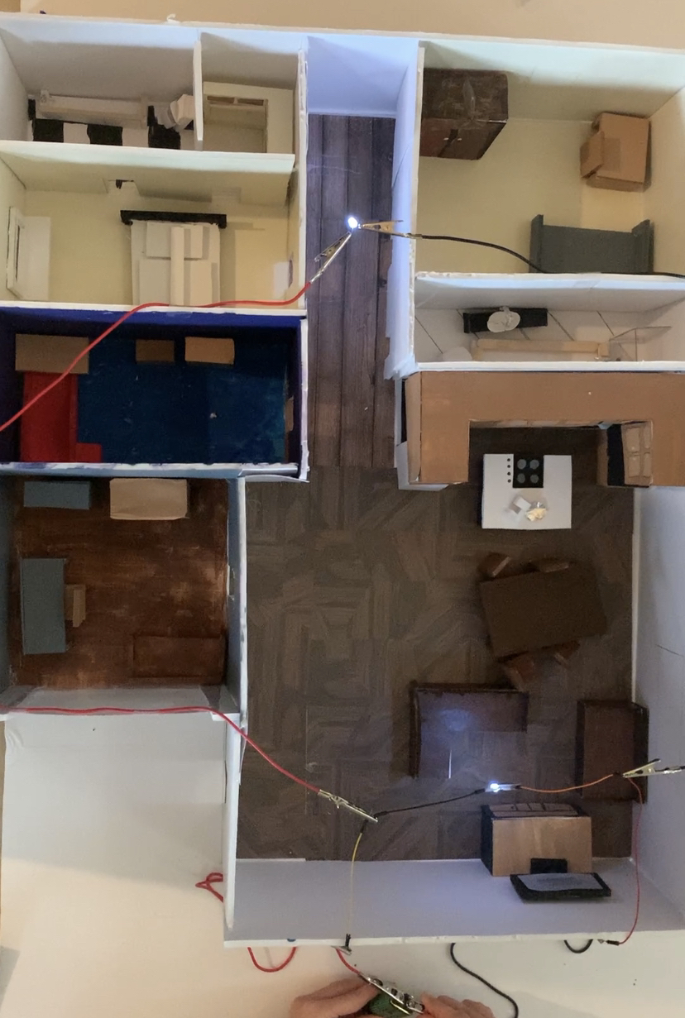

- After making the model, I am working on the 1-page final feedback and the portfolio to fill out everything to present to Mr. Cepeda.

Materials, page 6
The materials I used for this was
- Paper
- Index Cards
- Various colors of paint (acrylic)
- Foamboard
- Plastic
- Toothpicks
- Aluminum Foil
- Cotton balls
- Shirt Fabric
For the Lighting, I used
- Alligator clips
- White LEDs
- Jumper Wires
- A 12v Battery

Sketches, page 7
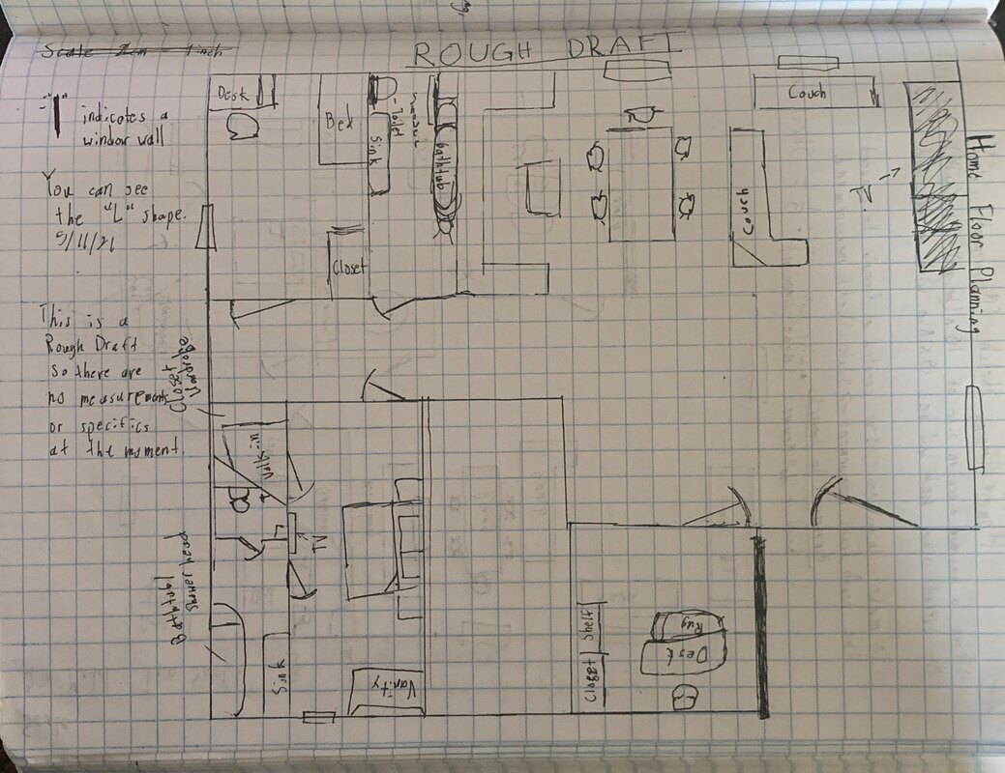
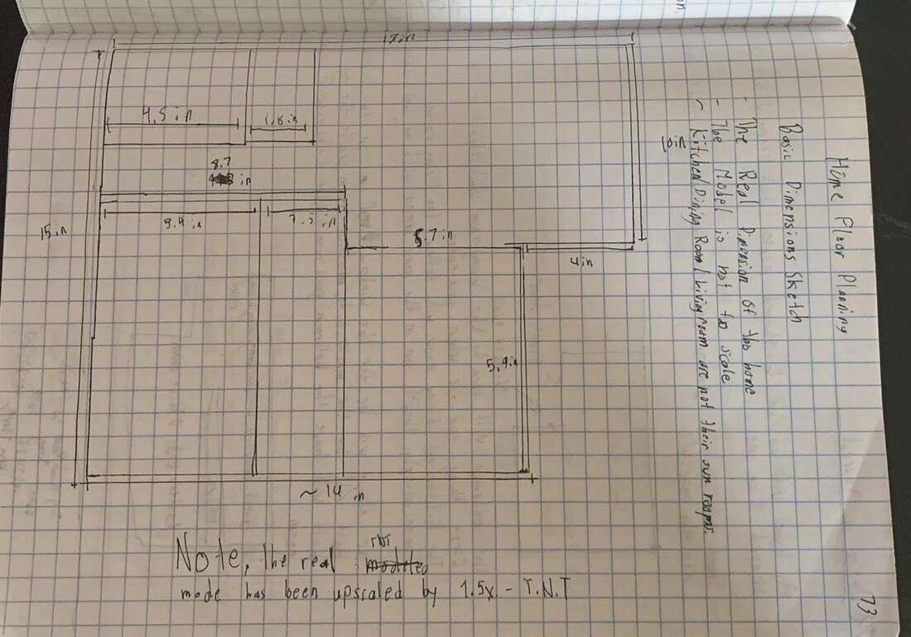
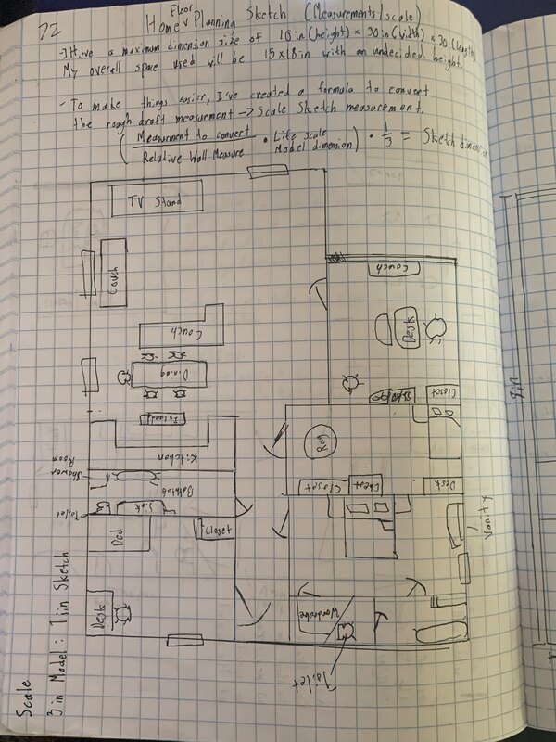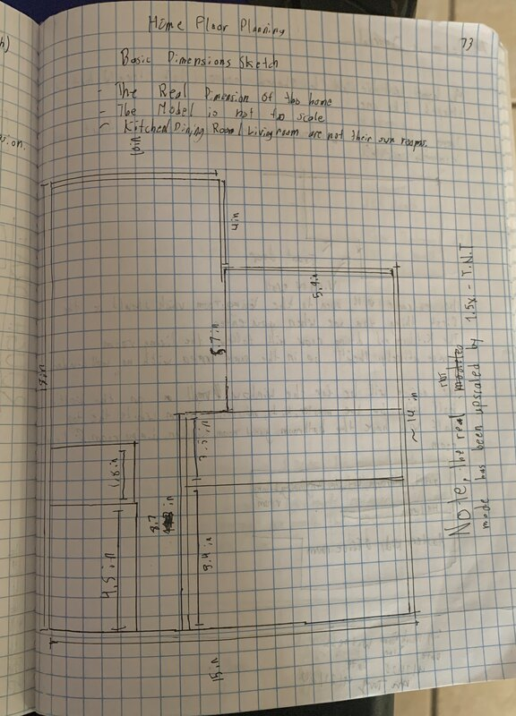
page 8

CAD Drawings, page 9
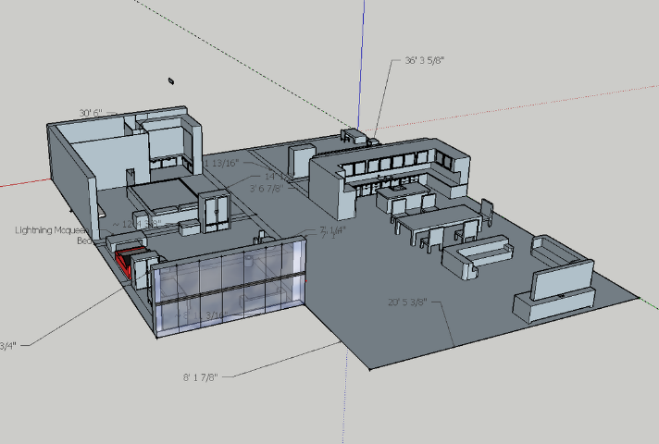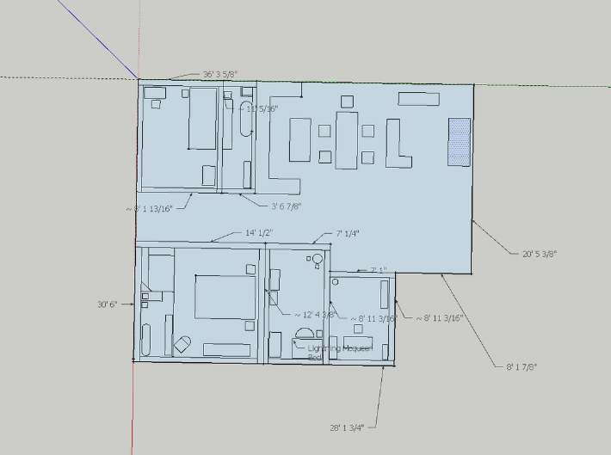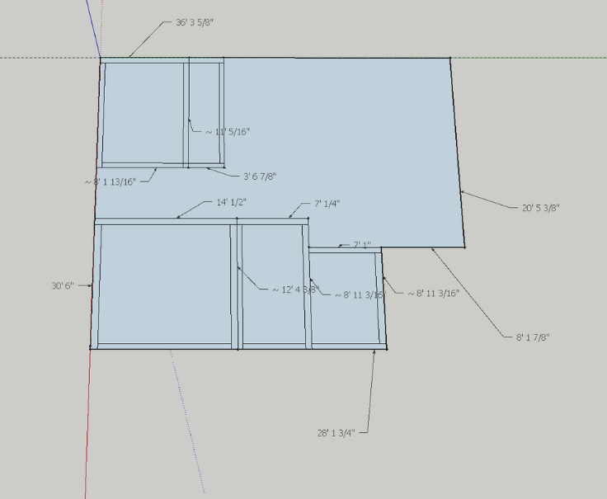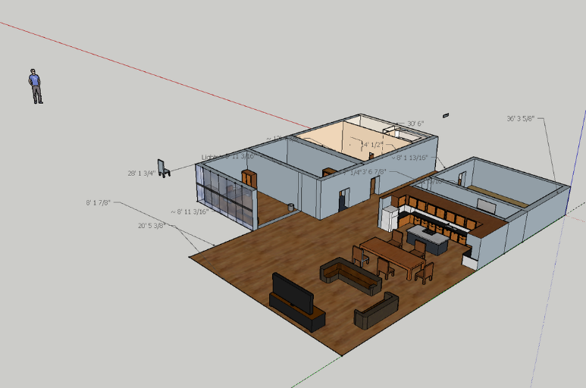

Page 10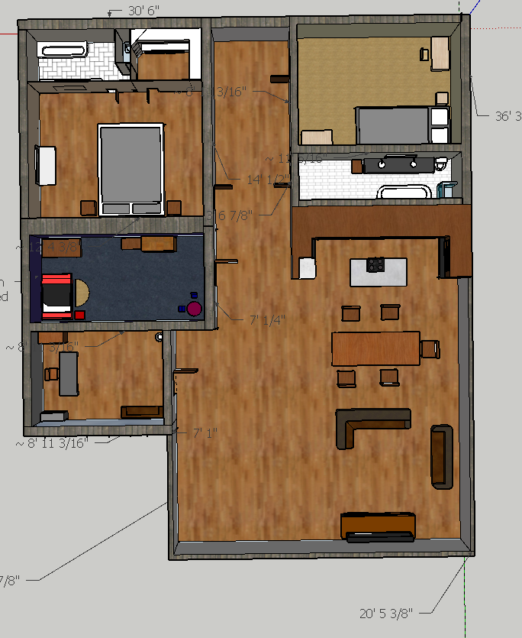

Page 11
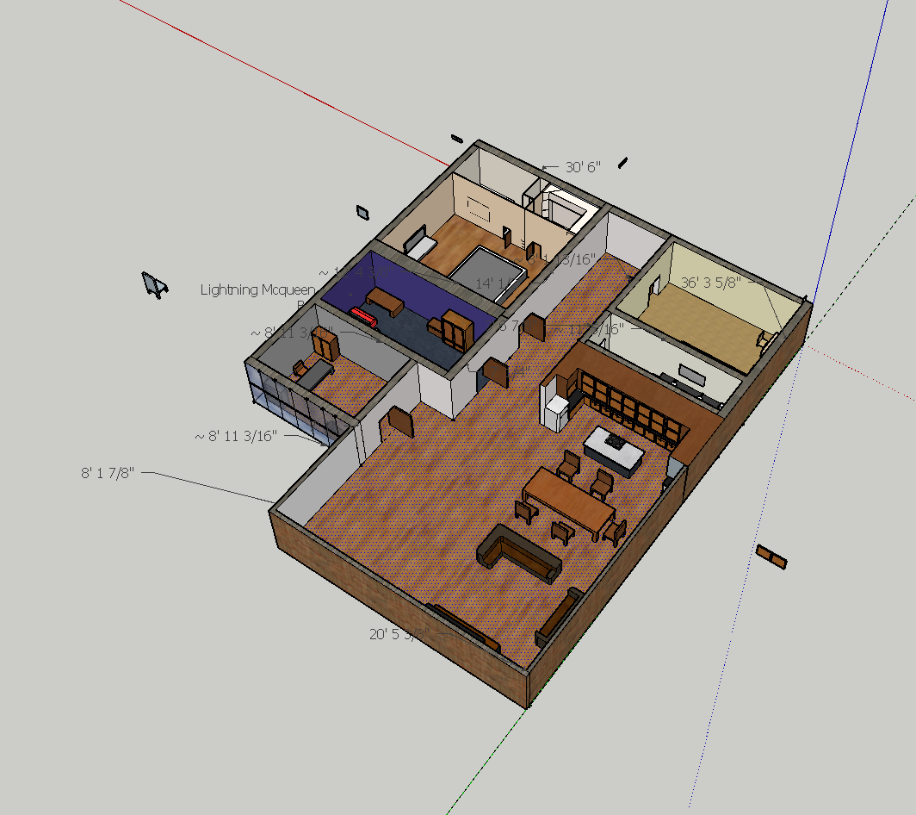

Testing and evaluating, page 12
There was nothing much to test as it was a model but I did test the functionality of the lighting for the home.
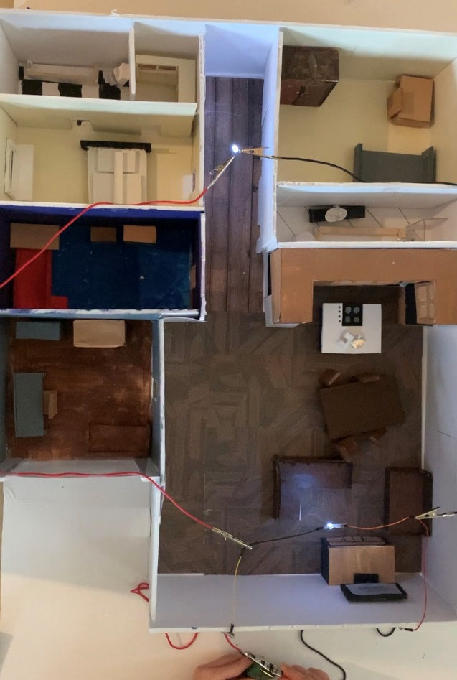
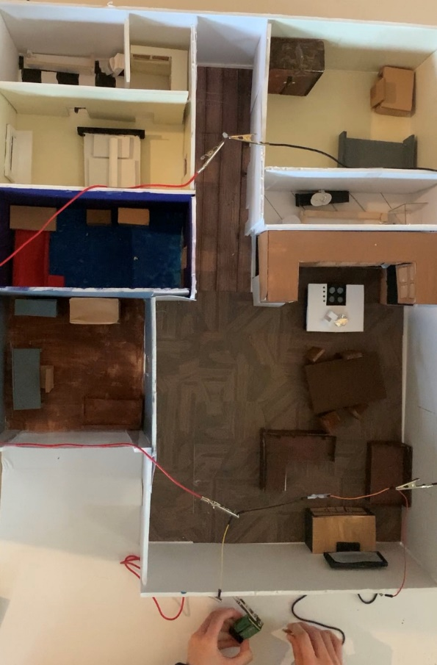
Unlit/not Connected Lit/Connected

Suggested Improvements, page 13
- I think that I should improve the detail to the small parts of the home even more. Maybe small Knick knacks.
- If possible, I think that there could have been a better way to wire the lighting. Perhaps I could have hidden it better or created a flip switch function.
- Some walling’s are slightly short, its best to resolve this to cover up the missing spaces with index cards.

Reflection
I think that this project came out better than I had expected it to be. Although it wasn’t as grandiose as what I really wanted, it was very satisfying to get it done and just marvel at what I myself have created. I think what I liked the most about this project was the 3D modeling. I just had fun with myself playing around and creating my home at the same time. I had some friends watch me screen-share me modeling and it was fun.

Feedback, page 14
These pages of feedback were written at a 5-to-4-day interval*
1. I’ve started to work on the sketches and the design of the entire home. It was difficult to imagine scales without any real reference so I had a ruler next to me at all times to help me visualize how things would, in theory, look. It was slightly difficult to draw and plan out everything because I had to tread carefully on the notebook, since I was writing in pen. I drew 3 sketches all that had varying styles and purposes for them. Rough draft, scale size, and redraw/refinement of the rough draft.
2. It’s my second day drawing and re-evaluating the floor planning. I had decided to cut some items out that I thought unnecessary and extra. The planning is finished and I will soon move over to SketchUp where I will 3D model the home. I am confident with this home. I like it because it isn’t excessive but its format is really nice to me. Nothing extravagant but nothing cheap-ish. It is slightly small which I am fine with. I like how the dining, kitchen, and living room all are in the same area with no separating walls.
3. I began to write my budget and etc. I used the budget assignment that was given to me a few months ago to help me. It actually did the job for me so I didn’t have to stress about writing another one because I already had one with me already. All I had to do was write my proposal which was relatively easy. Although I do think that I could have drawn a chart/draft for the budget. I didn’t in the end.
4. I started working on the sketchup/3D model. It wasn’t difficult because of my past experience with it. I think it was easy. I split up the 5 required 3d models into 5 different “layers” of the
Page 14
home. Things like “floor plan”, “walling”, and “finish product”. You get the idea. I just took the model, and copy and pasted it, and continued on it. Then copy and paste and done.
5. I spent the whole day working on the 3d model. Taking the methodical route was better than trying to wing and do it all. I took the methodical approach when drawing the floor planning and walling. But I winged it when I tried furniture. I took many screenshots. All of which sorted out in progression of the 3d model. I had some friends watch me 3D model through online video chat and had them advise me what looked good and what didn’t.
6. Working on the furniture proved very difficult for me. Unlike everyone else in the class, they had the sketchup workshop at their disposal. They can easily just download and drop things into their home. I have a dated version and I can’t seem to update/fix it. So that means I have to 3d model everything by manually. It wasn’t difficult but I was forced to find many work arounds to solve certain problems. Like modeling the car bed. That one was really weird to do.
7. I finished 3D modeling my home and I’m very satisfied with it. I have cut out some aspects of the home that were in the sketch. I am satisfied with the supplies I bought for the project. It was VERY expensive to buy so hopefully it won’t go to waste. The scale/size that I had originally drew for the real model was too small. The foamboard that I had available to me was more than what I needed. It had a lot of space so I decided to upscale the entire size by 1.5x. That means the whole place would be 1.5 times its original size that I had planned out. I drew out the floorplan only with a ruler.
8. After finishing the floor drawing on the workspace that would be for my model, I was faced with two choices on which to begin working on first. The actual wall or home, or the furniture. I
Page 15
decided to take a chess piece-like approach. I think it would bet better because creating the furniture was a much more difficult process than walling and the home itself. Also, I feel that the walling and size could be inaccurate and would really set me back if I had missed a few inches too small. I’d rather create the furniture first and place them in much like a chess board.
9. I spent about 2 weeks creating furniture, obviously taking break in-between. Not constantly working on it 24/7. After creating the furniture pieces, I painted over them which took some time to do. It wasn’t difficult but tedious. But, its nothing that music can fix. I placed the furniture pieces in and prepared to cutout walling.
10. I took measurements and decided to have my walls about 6 inches high, a slight 2 or 1 inch higher than the kitchen, which was the “tallest” room in the home. I took dimensions and wrote them down on a piece of paper to keep track of. It came out somewhat ok and I placed them in. After that I just put the furniture and was done with the home. One more thing was working with the circuits was nice. I like working with the circuits the most for the homes lighting because it needed me to reference previous projects that I though I wouldn’t ever go back to. The lighting in the home really brought the whole thing together in my opinion.

